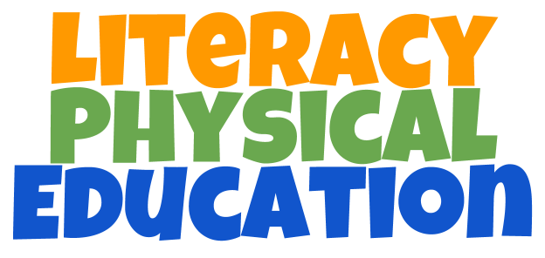

Joe McCarthy
Prior Lake, Minnesota, USA
Website: https://plus.google.com/+TheJmccarthy/posts
2012 MNSHAPE Elementary PE TOY

Contact Information:
jmccarthy@farmington.k12.mn.us
@JoeMcCarthy09 +JoeMcCarthy

What is this program about?

Literacy Physical Education is a program designed to help a specific grade level that is behind, based on the statewide reading assessment to each grade level standards.
Our data shows that students who are in our 12 week class will more than double their peers and up to five the national average on the winter assessment. Students come to the gym every day, fifteen minutes for 12 weeks. Every class embeds fluency, comprehension and spelling into movement activities. Students in this class learn how to combat “learned helplessness” by the end of the 12 weeks. Students will use whiteboards, markers and towels as their learning tools. Paper and pencil is another option for you to use.

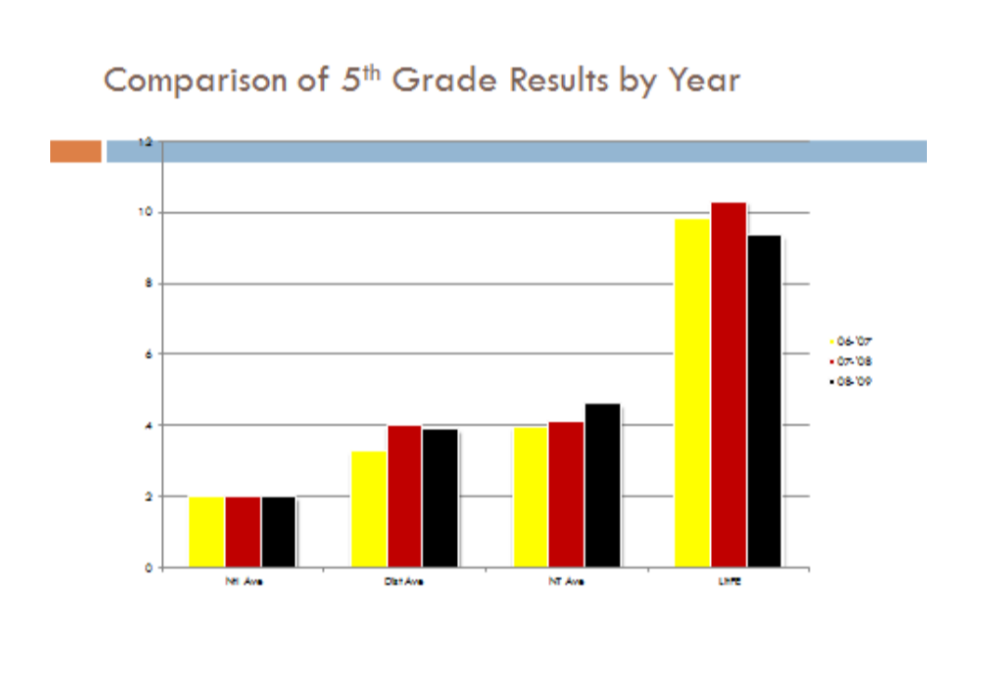

This booklet contains daily lesson plans that are used in this program. This booklet is used for grades 4 & 5, but can be modified for any age group. Every lesson embeds fluency, comprehension or spelling into movement activities.

https://www.youtube.com/watch?v=dFF8JoEp5gw – Video description of a lesson.

